



E-PROJECT DOCUMENTATION

***Team Members:***

* Muhammad Hasnain Siddique
* Tayyaba M.Saleem
* Subhan

­

**ACKNOWLEDGEMENT**

I would like to acknowledge all those who have given me moral support and helped in making the project a success.

I wish to express my gratitude to e-Project Team at Head Office who guided and helped me. Also, I would like to express my gratitude to all the staff members of my center for not only providing me opportunity to work with them on this project, but also for their support and encouragement throughout the process.

I also express my sincere gratitude to e-Project Team from Aptech Head Office and my project guide at the organization for his valuable guidance and support for completion of this project.

**Table of Content**

|  |  |
| --- | --- |
| Content | Page No. |
| Introduction ---------------------------------------------------------------------------- | **03** |
| Requirement Specification ---------------------------------------------------------- | **04** |
| Descriptions of All Pages ------------------------------------------------------------ | **05** |
| Screenshots ---------------------------------------------------------------------------- | **07** |
| Backend Explanation ---------------------------------------------------------------- | **16** |

**INTRODUCTION**

One way of communicating wishes is by sending flowers. So, our client “java florist” wants to develop a website which would help people to communicate wishes by sending flower bouquet on special occasion. Java Florist offers professionally designed flower arrangements for all occasions like Birthday, wedding, new baby, thank you, fathers’ day, mothers’ day etc. The services that will be offered by java florist include delivery of bouquets in Mumbai and surrounding areas, and can even handle flower delivery nationwide through there network of trusted florists.

**REQUIREMENT SPECIFICATION**

Our client, java Florist wants the following actions to be implemented.

1. The application will have a web page which have links or option home, My account, about flowers, view cart, florist registration etc.

2. the home page will also have link for different occasions and when the user clicks on any occasion the bouquets available with that occasion would be displayed with their price.

3. If the user wants to book any bouquets, he has to register himself. At a time, the user can book more than one bouquet. At the time of booking the bouquets gets attached to cart and the total price will be calculated.

4. The price would be paid through credit card.

5. After paying the money it should also collect the information to whom the bouquet has to be delivered, their name, address, phone no and the message.

6. For messages there would be dropdown list having all the occasion in the list. According to the selected occasion predefined messages will be displayed and the user can choose one of them. Also, he can write his own message in the text area provided.

7. The bouquet will be delivered with in the five hours of the booking. The working hour of the florist is morning 9 a.m. to evening 9 p.m. If the booking order is within the five hours of working hour the bouquet will be delivered on the same day otherwise it will be delivered on the next day.

8. Admin login should able to update and delete the bouquets available, there price etc.

**Descriptions of All Pages**

**Home**

Starting with the home page, cuz that’s where it all starts  
so at the top there’s the navigation bar, having a logo and pages links.

Following is a normal landing page with a background image slider and some text and a button leading nowhere. Below it is a little about us section containing: some text and an image. An then there’s a footer containing the working hours.

that’s all for the home page

**Shop**

Now for the store page, at the top it’s the same navigation bar, it’ll appear in like every page.

Well, now on this section you can find all the flowers that we have on our site. The flower card contains an image of the flower, name and price. As you click on any card it’ll redirect to the product page of that flower, there you can see the full details of that flower and you can set the quantity before adding it to the cart.

**Register / Login**

On this page, first you’re gonna have to register yourself, at the bottom of the login button register hyperlink and as you click on that you’ll be redirected to the register page and there you’ll see text fields such as First Name(this’ll be used as the username for login), Last Name, Password, confirm password, date of birth, gender, phone number, address and finally the register button. After filling those all and clicking the register button, you’ll be registered and redirected to the login page.   
here at the login page, there’s just the username and the password, enter those and click the login button, you’ll be logged in and redirected to the home page.  
and the you’re free to add products to the cart and order them.

**Cart**

Here you’ll see all the products that you’ll have added to the cart, here you can order the products, but you can only order one product at time. After clicking on “Place Order”, you’ll be redirected to another page, here you’d have to enter your delivery details and card details to pay, the card details don’t work at all (obviously), after ordering you can see your product on the “My orders” page, you’ll see all the delivery details there.

**Admin Panel**

To get to the admin panel, you just normally have to login like any other, by the credentials for it are: **username:** admin, **password:** admin (check the caps), and as usual you’ll be redirected to the home page and the you’ll see something new in the navigation bar “flowers”, go there and you can edit and delete all the flowers/products details and at the top of all the cards, there’s a “add new Bouquet” hyperlink, click that and from there you can add new flowers to the site.

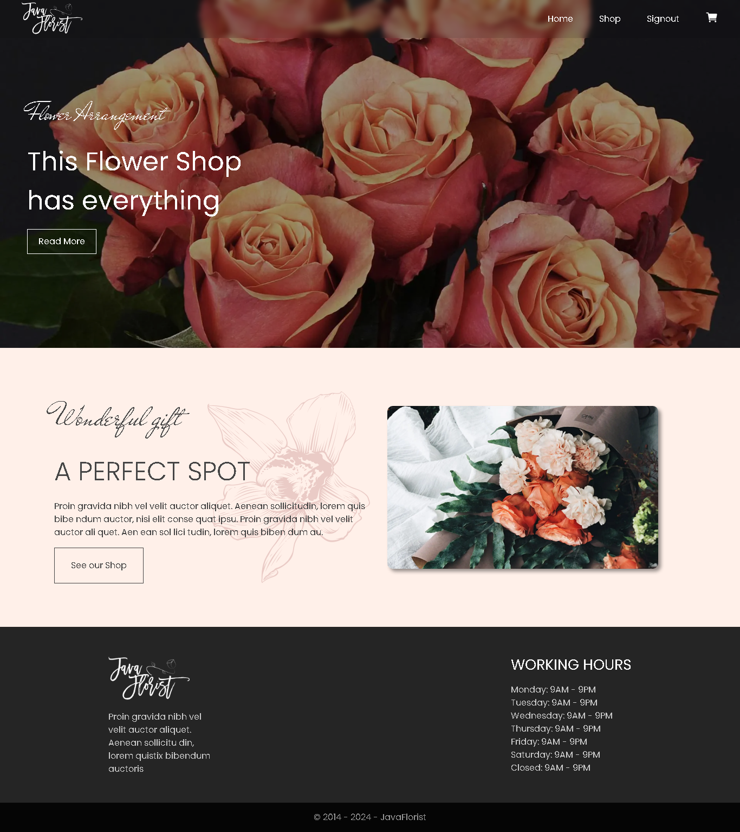

Home

ScreenShots

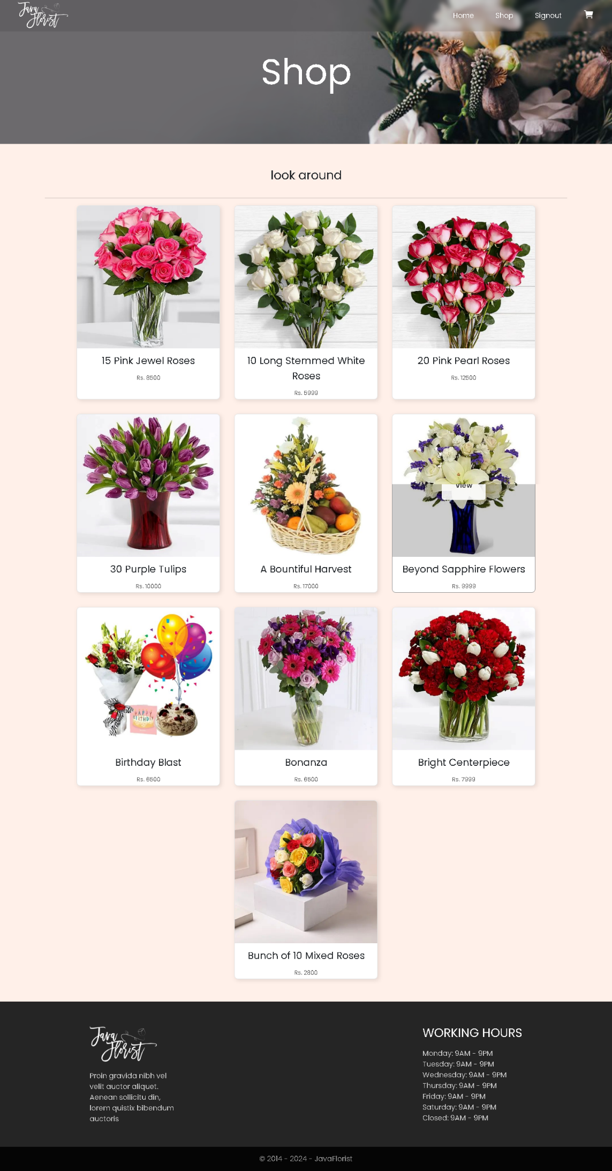

Shop

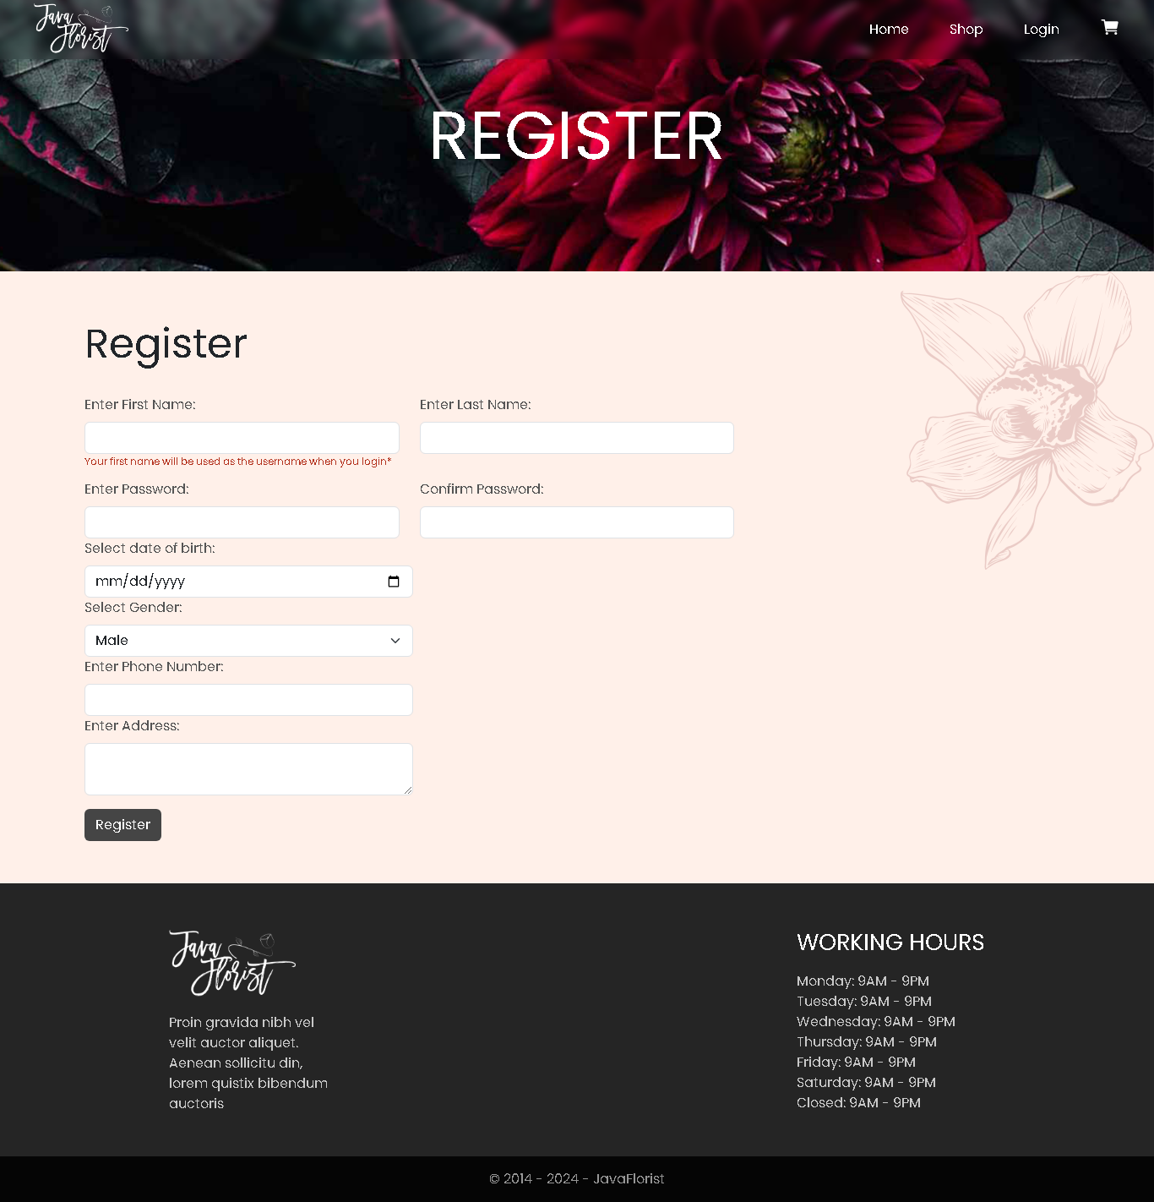

Register

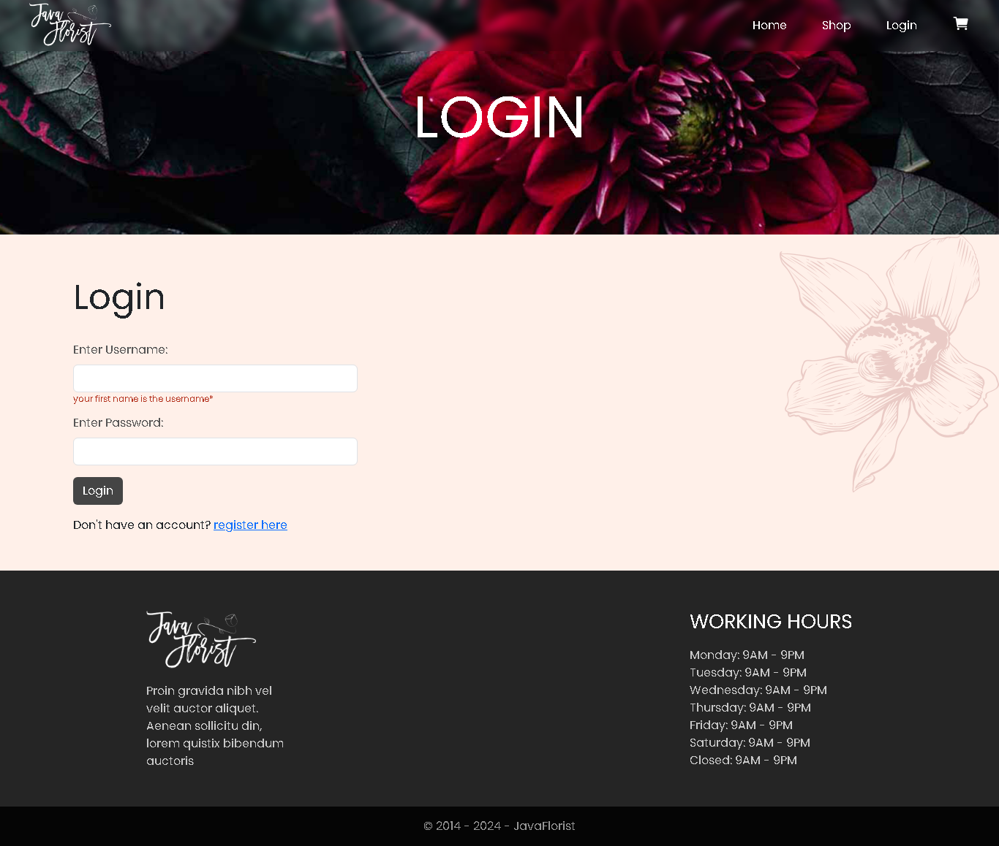

Login

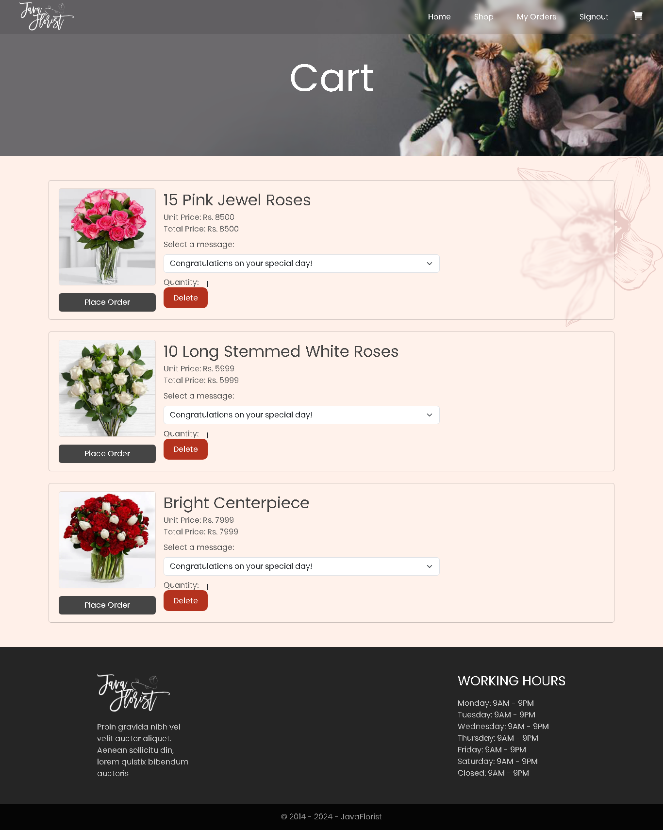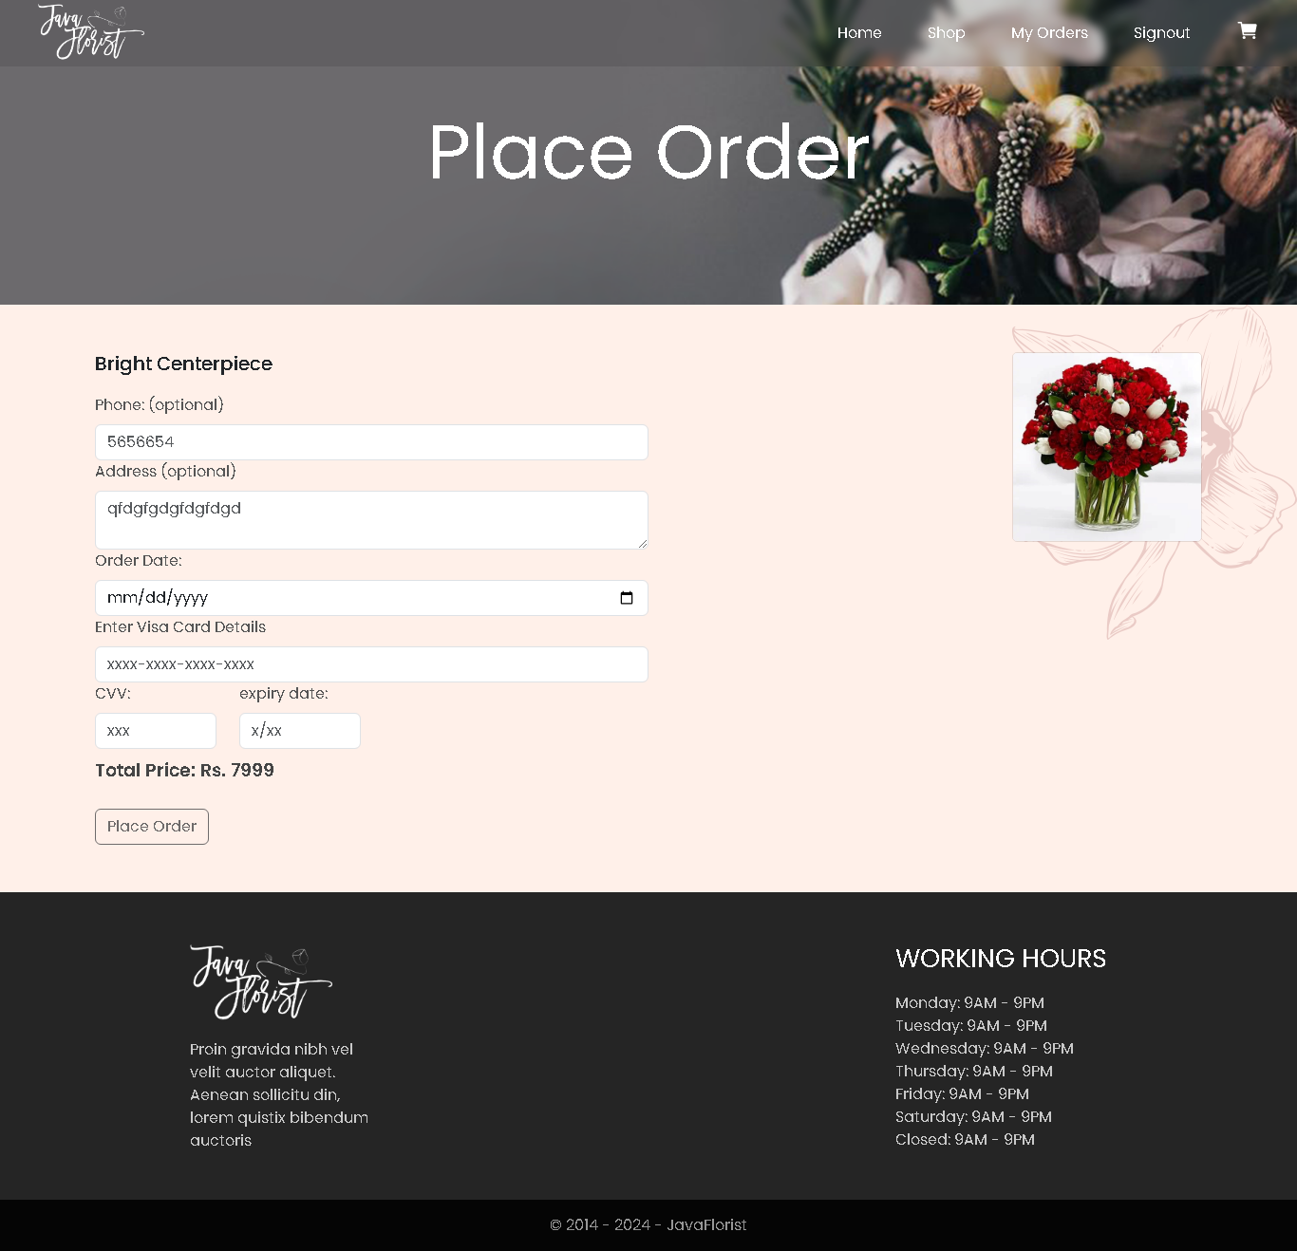

Cart

Place Order

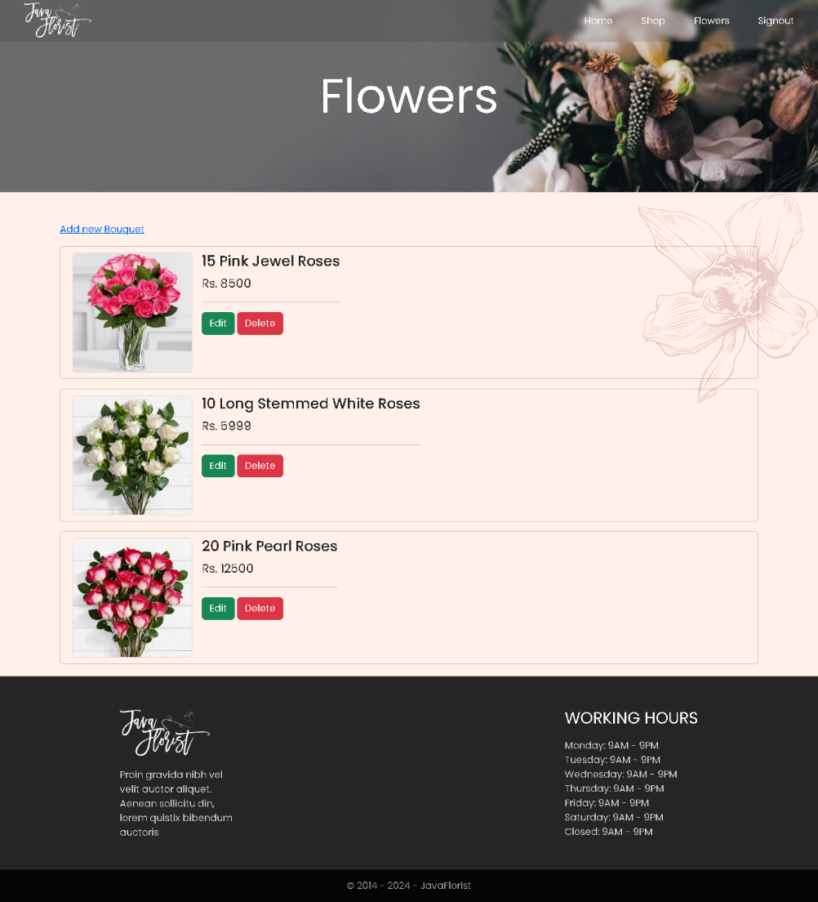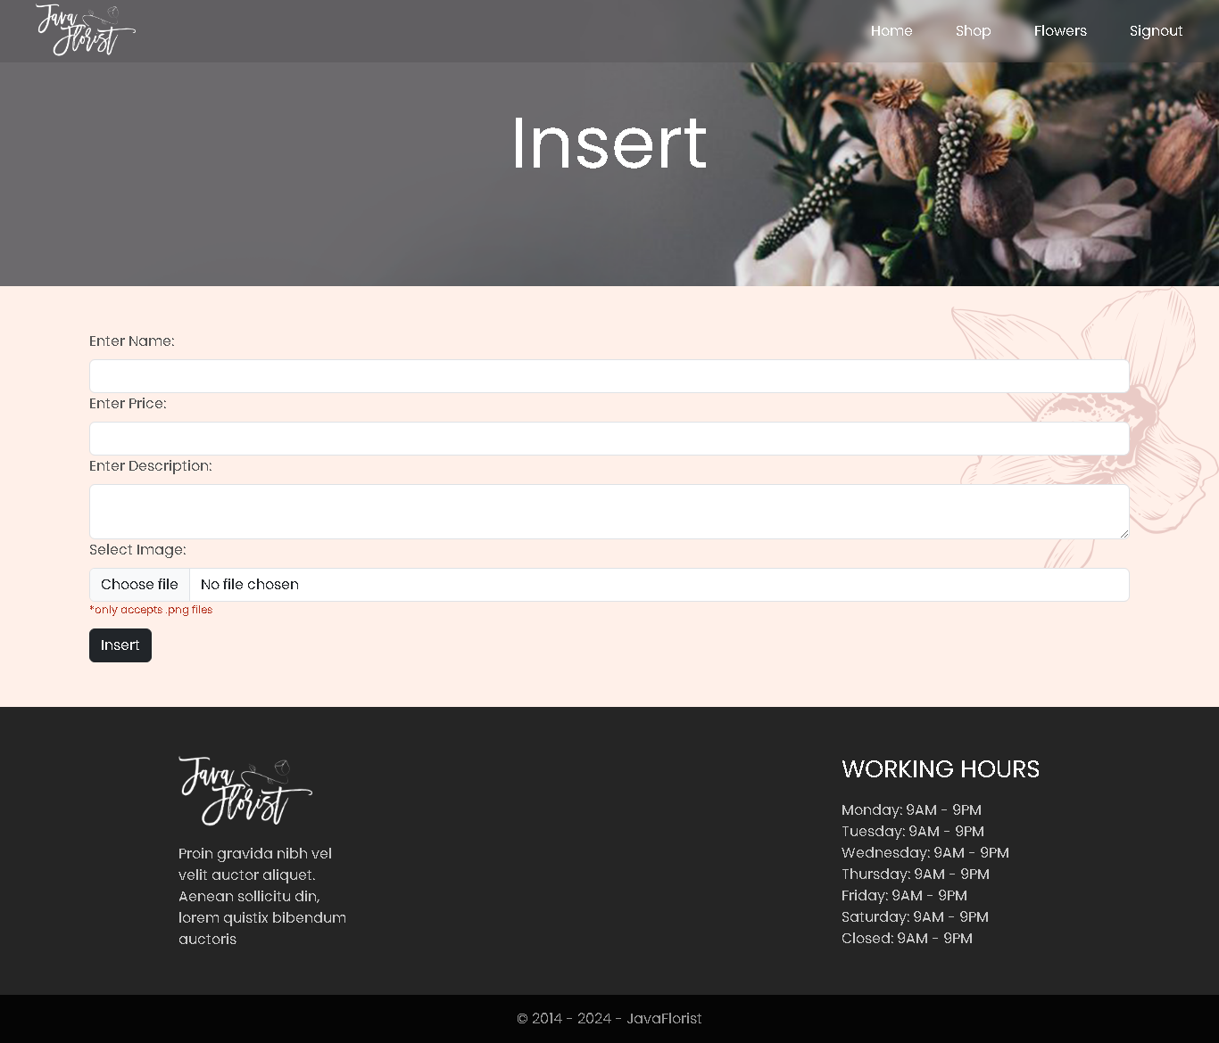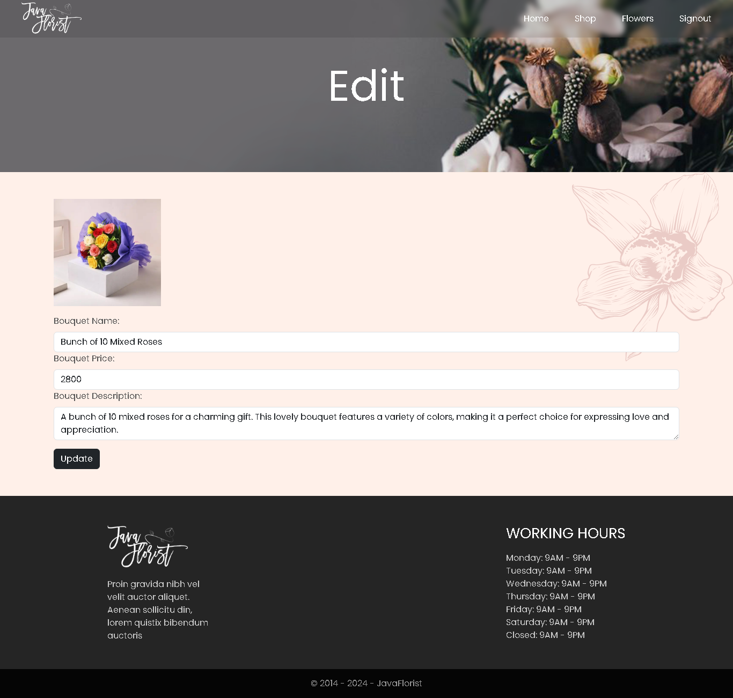

Admin Panel (Home)

Admin Panel (Add new)

Admin Panel (Edit)

**Backend Explanation:**

**Database Tables:**

* CUSTOMER
  + CUSTID
  + FNAME
  + LNAME
  + PASSWORD
  + DOB
  + GENDER
  + PNO
  + ADDRESS
  + ROLE
* BOUQUET
  + BOUQUETID
  + NAME
  + PRICE
  + DESCRIPTION
  + IMG
* OCCASSION
  + OCCASSIONID
  + MESSAGE
* ORDER
  + ORDERID
  + CUSTID
  + BOUQUETID
  + OCCASSIONID
  + ORDERNAME
  + ORDERADDRESS
  + ORDERPHONE
  + ORDATE DATE
  + QUANTITY
  + TOTALPRICE
* CART
  + CARTID
  + CUSTID
  + BOUQUETID
  + QUANTITY

**Data flow:**

Just read the code… I don’t feel like explaining it anymore, it’s such a pain, I’m the only one working on this thing, writing this documentation down on the very last day, I’m dead tired, I got other things to do too, there’s a file named “JavaFlorist.bak” it’s the database you can restore it all in the SQL Management studio also a file named “table.sql” incase the table doesn’t restores due to some error or such, this file has all the queries, you can run those after making a database with the name “javaflorist”, I’ll also add a video named “demonstration” this video will have all the work through of this, kay’.

PS. For this project’s evaluation, please make the remark really detailed, I want them details…

This Concludes the Documentation of E-Project